**VERB PATTERNS**

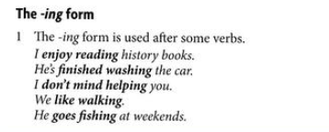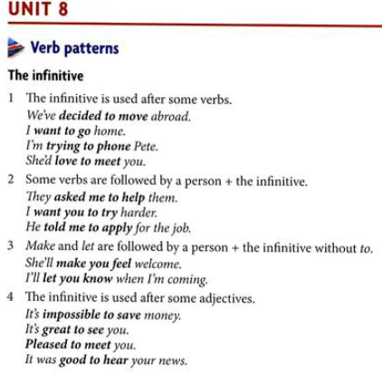

*I’m* ***lucky to have*** *a house.*

*I’m* ***delighted to see*** *them****.***

**Verb + sb + *to* + infinitive**

**warn**

*He warned me to go there.*

***!!! neg.***

*He warned me* ***not to do*** *that.*

**Verb + sb + infinitive (not to)**

**let**

**make**

*You made me go.*

**hope**

**manage**

**!!!**

**dare - can be without to**

*They don’t dare disagree.*

**help - can be without to**

*We helped clean up the kitchen.*

**adore**

**can’t stand**

**can’t help**

**don’t mind/ would you mind?**

**go + sports and activities**

*I go swimming.*

**give up**

**loathe**

**keen on**

**succeed in**

*I’m sorry* ***for worrying you/hurting you/interrupting you****.*

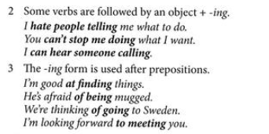

**VERBS** + -ing **or** to + infinitive

**I remembered/forgot posting** the letter.

(*I have/don’t have a memory now - I did it*). **PAST**

**I remembered/forgot to post** the letter.

(*I remembered myself to post the letter - pripomínal som si, aby som nezabudol*).

**I NEED TO/NEEDED TO DO stg,**

**I stopped drinking** coffee. (*I don’t drink anymore*). Action is no longer continuing.

**I stopped to drink** a coffee. (*I stopped in order to have a coffee*).

**I tried counting** sheep. (trying something as an experiment as a solution to a problem)

*I tried turning the computer off and on.*

**I tried to count** sheep. (something is difficult but you are making an effort to do it)

*I’m trying to learn Japanese but it’s very difficult.*